Investing a Percentage of Your Income (I) - Corrected Full Answer

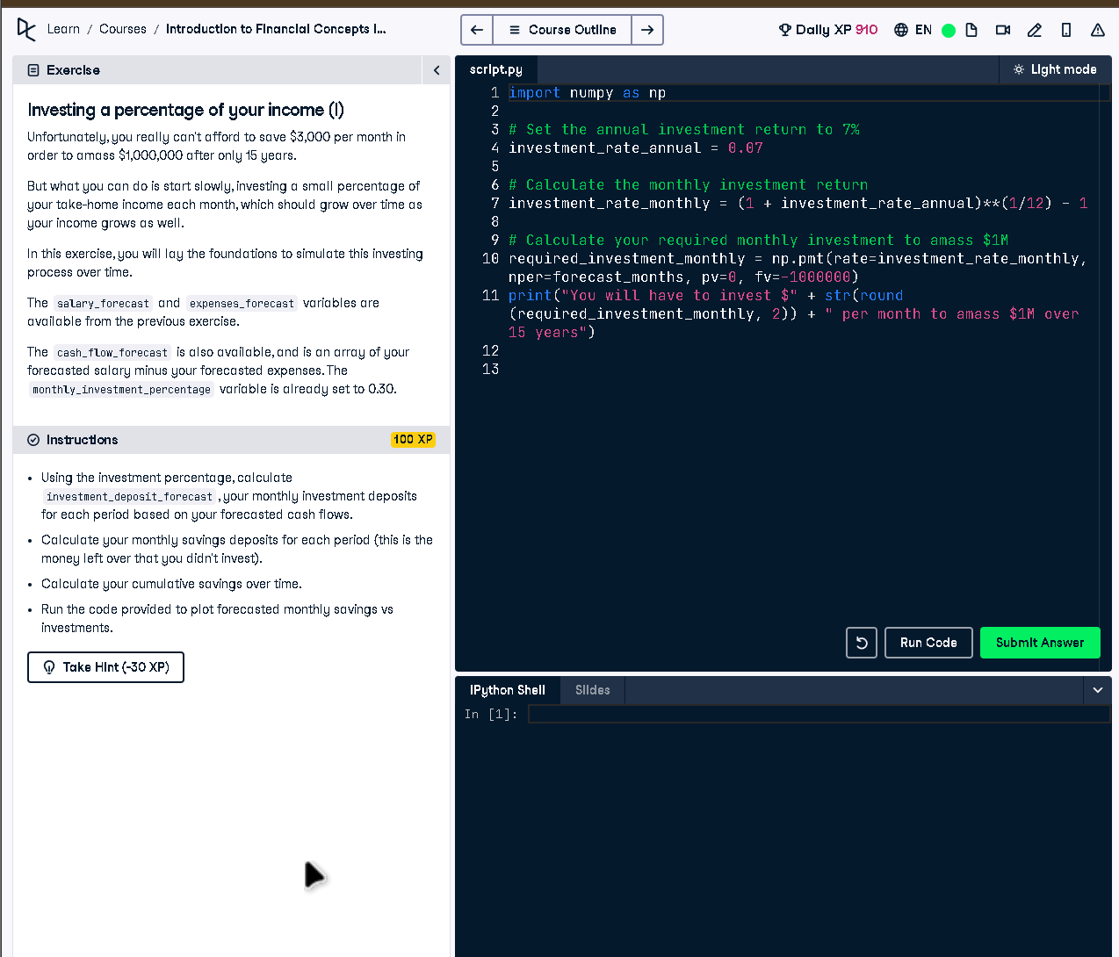

# Full Code Answer:

import numpy as np  
  
# Calculate your monthly deposit into your investment account  
investment_deposit_forecast = cash_flow_forecast * monthly_investment_percentage  
  
# The rest goes into your savings account  
savings_forecast_new = cash_flow_forecast * (1 - monthly_investment_percentage)  
  
# Calculate your cumulative savings over time  
cumulative_savings_new = np.cumsum(savings_forecast_new)  
  
# Plot your forecasted monthly savings vs investments  
plt.plot(investment_deposit_forecast, color='red')  
plt.plot(savings_forecast_new, color='blue')  
plt.legend(handles=[investments_plot, savings_plot], loc=2)  
plt.show()

# Question:

How do you calculate and compare monthly investments and savings when investing a fixed percentage of income?

# 20-word Explanation (Question):

Investment and savings split is calculated by distributing cash flows based on a fixed investment percentage every month.

# Answer:

Multiply cash_flow_forecast by monthly_investment_percentage for investments, allocate the rest to savings, and plot both for comparison.

# 20-word Explanation (Answer):

The remaining income after investments is saved, while cumulative tracking and plotting provide visual insights into growth patterns.